TENDER DOCUMENTS
Category-A: Purchase/installation of Windows Blinds:
Curtain/Blinds under Project PAAF
S.No | Description | Unit | QTY | Rate(Rs) with GST | Amount (Rs) with GST
1 | i-(Office's in Academic Block(G,1st & 2nd Floor) II-Lecture Theater's & Computer Lab III-Seminar & Theater Halls IV- Examination Center V-STC & Provost office  Roller Blinds: the blind system consists of a quoted Aluminium tube of 38mm diameter (including cover) with the provision of fabric clamping. The fabric is rolled up and down through a chain drive system with built-in drive gear and an over-run brake system. The side brackets are universal types suitable both for wall and ceiling mounting. The bottom end of the fabric is rolled over an oval shape aluminium tube with provision to lock the fabric. including fixing/hardware complete in all respect. | Sft | 5878
2 | I-Class Rooms II-Sports Gym S/F for curtain, best quality cotton fabric, weather 100% cotton or cotton/polyester mixed, tend to be heavy in weight and attractive in color. including fixing /hardware complete in all respect. | Sft | 6170.00

* Price must be quoted in PKR with fixing, and installation charges.
** The bidder must sign & stamp each page of the bidding document.

Category-B: (Purchase of Tent/Catering items)

SPECIFICATION OF TENT/CATERING ITEMS
S. No | Item | Type | Specification | Size | Quantity | Unit Price with GST | Total
1 | Chairs | Simple/ Common Chairs | Frame: made of stainless-steel Pipe shall not be less than ¾” with 18 gauge  Material: Back and sitting material should be good quality plastic or Polypropylene | 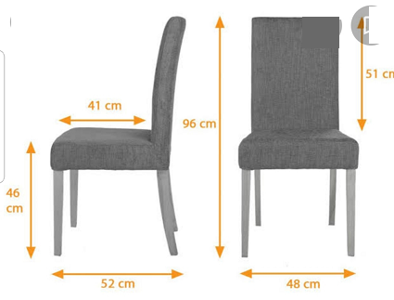 | 500
2 | Chairs | Foam/Sofa Chairs | Frame: made of stainless-steel Pipe shall not be less than ¾” with 18 gauge  Material: Back and sitting material should be high quality foam covered in good quality Cloth |  | 100
3 | Dining Table | Rectangular (folding) | Frame: made of stainless-steel Pipe shall not be less than ¾” with 18 gauge.  Serving Surface Material: should be stainless steel covered/coated with good quality leather | 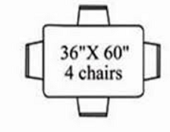 | 150
4 | Qanat | Umbrella | High-quality cloth double-layered having Parachute, must be waterproof and weather-resistant | Size sufficient for covering/serving 300 people/chairs | 2
5 | Qanat | Umbrella | High-quality cloth double-layered having Parachute must be waterproof and weather-resistant | Size sufficient for covering/serving 150 people/chairs | 4
6 | Qanat | Fence/parda | High quality and durable double-layered jersey cloth with the parachute | Length 15 feet, Height 7 to 8 feet | 30
* Price must be quoted in PKR with fixing, and installation (if required) charges.
** The bidder must sign & stamp each page of the bidding document.

Category-C: Purchase of Electronic/electric items

S no | Description | Qty | warranty period (at-least) | Unit Price with GST | Total Price (with GST)
1 | Smart LED TV Original 42”  (Samsung, Sony or equivalent) | 02 | 01 year
2 | Refrigerator (11 sft)  (Dowlance, Haier, Kenwood, Orient, or equivalent) | 05 | 05 years
03 | Deep Freezer (4 feet)  (Waves, National or equivalent) | 06 | 03 years
04 | Geysers (60 liters)  (Welcome, Super Asia, or equivalent) | 21 | 01 year
05 | Air Conditioner (02 ton), inverter  (Gree, orient, Haier or equivalent) | 03 | 03 year
06 | Air Conditioner (1.5 ton) inverter  (Gree, orient, Haier or equivalent) | 05 | 03 year
- Price must be quoted in PKR with fixing, and installation charges.
- The bidder must have to submit an authorization certificate with the tender document.
- The bidder must give warranty as mentioned against each item.
- The bidder must sign & stamp each page of the bidding document.

